**Agile and Scrum: A Clear Overview**

**1. Introduction to Agile**

Agile is not a tool or a methodology—it is a **mindset and a way of working**. It is primarily used in project management and software development but has now spread to many other industries. Agile focuses on **delivering value quickly, adapting to changes, and working closely with customers**.

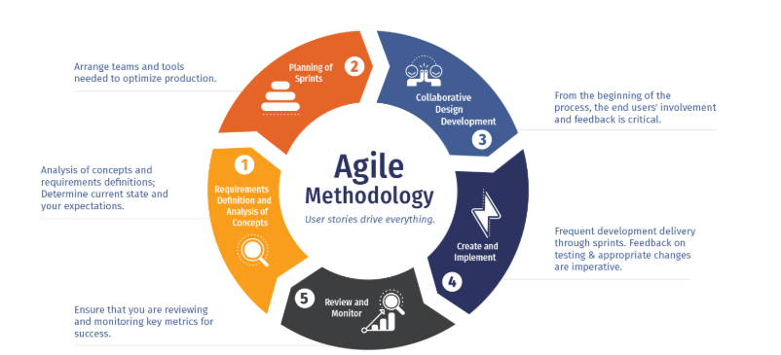

**Why Agile Was Needed**

In the past, traditional models like the **Waterfall model** were widely used. These models required all requirements to be fixed at the start. If customer needs changed midway, it was costly and difficult to adapt. Agile emerged as a response to this challenge, giving teams the ability to **be flexible, iterative, and customer-focused**.

**Agile Principles (from the Agile Manifesto)**

1. **Customer satisfaction** through early and continuous delivery.
2. **Welcome changing requirements**, even late in development.
3. Deliver working software frequently (weeks rather than months).
4. **Business and developers work together** daily.
5. Build projects around motivated individuals and trust them.
6. Face-to-face communication is the most effective way to share information.
7. Working software is the **primary measure of progress**.
8. Maintain a constant pace for sustainable development.
9. Focus on technical excellence and good design.
10. Simplicity—the art of maximizing work not done—is essential.
11. Self-organizing teams produce the best results.
12. Teams regularly reflect on how to improve and adjust accordingly.

**Benefits of Agile**

* Responds quickly to change.
* Keeps customers involved throughout.
* Reduces risks by delivering in small increments.
* Encourages collaboration and teamwork.
* Leads to higher-quality products.

**2. What is Scrum?**

**Scrum** is one of the most popular frameworks under the Agile umbrella. Think of Agile as a **philosophy** and Scrum as one **practical way to apply it**.

Scrum structures work into **short, time-boxed cycles** called **Sprints**, usually lasting **2–4 weeks**. Each Sprint results in a usable product increment.

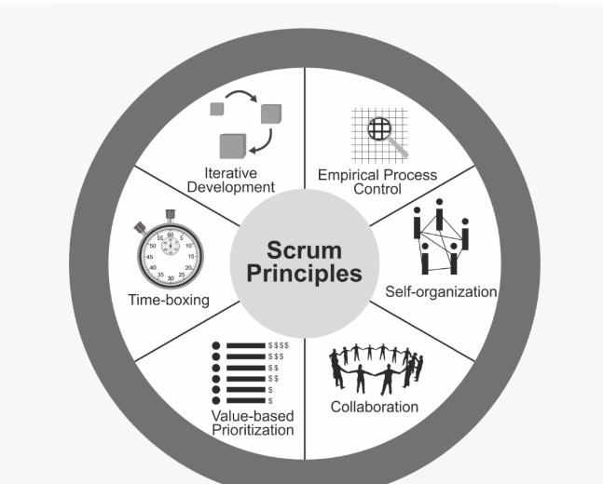

**Scrum Values**

Scrum is built on **five values** that guide teams:

* **Commitment** – to the goals of the team.
* **Courage** – to tackle tough problems.
* **Focus** – on the work of the Sprint.
* **Openness** – about challenges and progress.
* **Respect** – for one another as capable professionals.

**Scrum Workflow**

1. **Product Backlog** → A list of all features, improvements, and fixes.
2. **Sprint Planning** → Team chooses items to complete in the Sprint.
3. **Sprint Execution** → The development team works on selected items.
4. **Daily Scrum** → A 15-min stand-up to sync progress.
5. **Sprint Review** → The team demonstrates completed work to stakeholders.
6. **Sprint Retrospective** → Reflect and improve for the next Sprint.

This cycle repeats until the product is complete.

**3. Scrum Roles**

Scrum defines **three key roles**, together forming the **Scrum Team**.

**Product Owner (PO)**

* The **voice of the customer**.
* Manages the **Product Backlog**, ensuring items are prioritized by business value.
* Defines what features should be built and in what order.
* Works closely with stakeholders and the team to maximize product value.

**Example:** For an e-commerce app, the PO decides features like “shopping cart,” “wishlist,” and “payment gateway” and prioritizes them.

**Scrum Master (SM)**

* A **servant leader** and facilitator for the team.
* Ensures Scrum principles are understood and followed.
* Removes **impediments** (technical or organizational) that block the team.
* Helps improve team productivity and collaboration.
* Facilitates all Scrum ceremonies (planning, daily scrum, review, retrospective).

**Example:** If the team is stuck waiting for server access, the Scrum Master ensures this gets resolved quickly.

**Development Team**

* A **cross-functional, self-organizing group** of professionals.
* Builds, tests, and delivers the product increment.
* Team size is typically 5–9 members.
* Includes developers, testers, designers, and sometimes DevOps engineers.

**Example:** In the same e-commerce app, developers code the cart feature, testers validate it, and designers refine the UI—all within one Sprint.

**4. Scrum Artifacts**

Scrum uses three main artifacts:

1. **Product Backlog** – A prioritized list of everything that might be needed in the product. Managed by the Product Owner.
2. **Sprint Backlog** – A subset of backlog items selected for the Sprint. Managed by the development team.
3. **Increment** – The working product delivered at the end of each Sprint.

**5. Example in Practice**

Let’s imagine a startup building a **food delivery app**.

* **Product Owner** creates a backlog with features like login, restaurant search, cart, and payment.
* In the first **Sprint**, the team focuses on “User Login” and “Browse Restaurants.”
* Every day, they meet for a **Daily Scrum** to discuss progress.
* At the end of two weeks, they demo login and search features in the **Sprint Review**.
* In the **Retrospective**, they decide to improve code review speed in the next sprint.

This process repeats until the complete app is launched.

**6. Conclusion**

* **Agile** = A mindset that values flexibility, customer collaboration, and rapid delivery.
* **Scrum** = A framework to put Agile into practice.
* **Scrum Master** = A coach and facilitator for the team.
* **Product Owner** = Represents the customer and manages priorities.
* **Development Team** = Builds and delivers the product increment.